Name: Ekta Narayan Sawant
Roll No.: 2401103
Class: T2 Batch: T22

ASD&DO Experiment No. 09

Lab outcomes :
LO4: Containerize, orchestrate, and deploy applications using Docker, Docker Compose, Kubernetes, and cloud infrastructure tools.
Theory:
Step 1: Create or verify your AWS account 1. Open the AWS Management Console .
- Sign in to your AWS account.
- Select the Mumbai region (ap-south-1).
- Open the EC2 Dashboard and check that your account is ready to launch instances.
The account must have permissions to create EC2 instances and use the required networking resources.
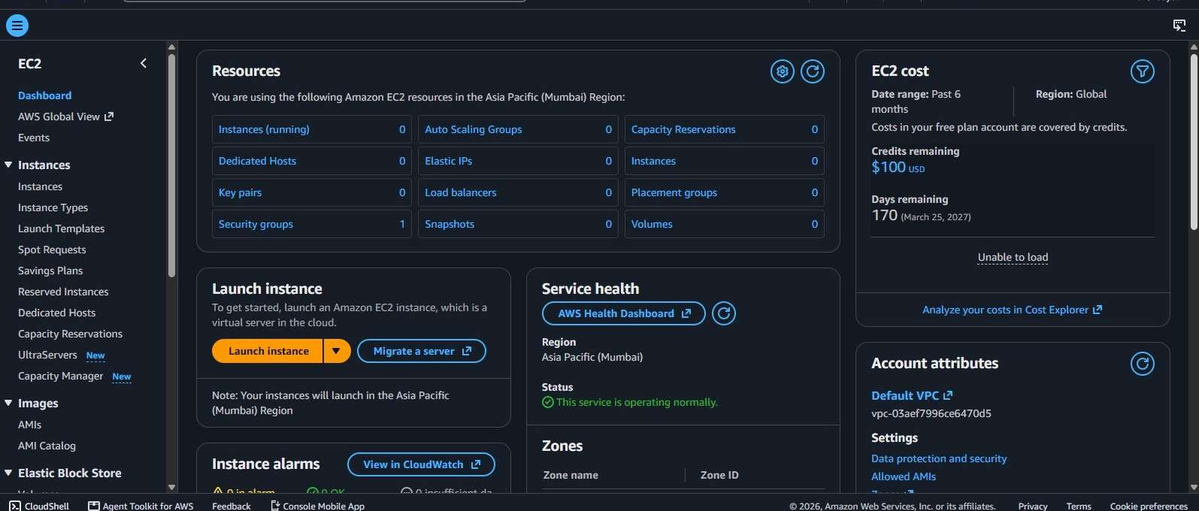
Step 2: Install Terraform on Windows
- Visit the official Terraform installation page .

- Download the Windows AMD64 ZIP package.
- Extract terraform.exe into a folder, for example: C:\Terraform

- Add C:\Terraform to the Windows PATH environment variable.
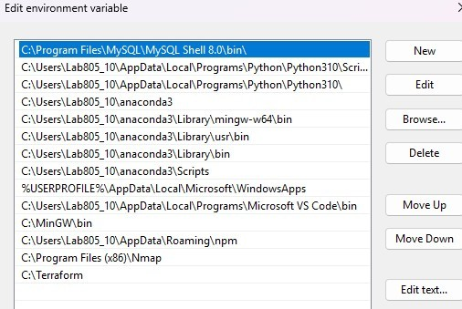
- Open a new Command Prompt or PowerShell window.
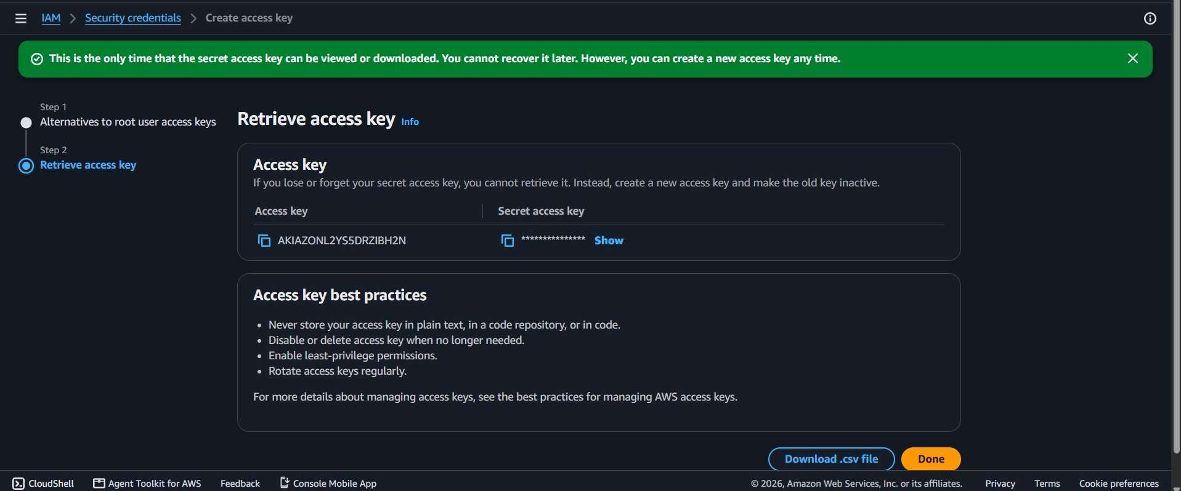
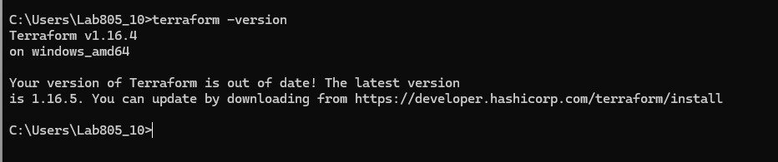
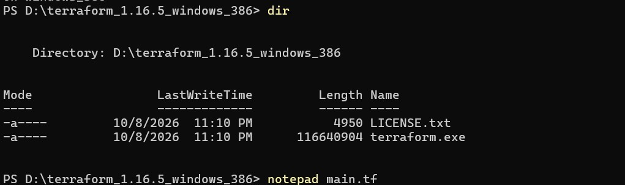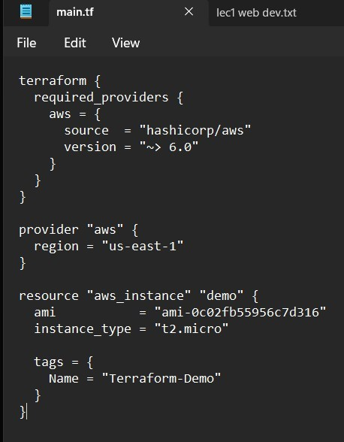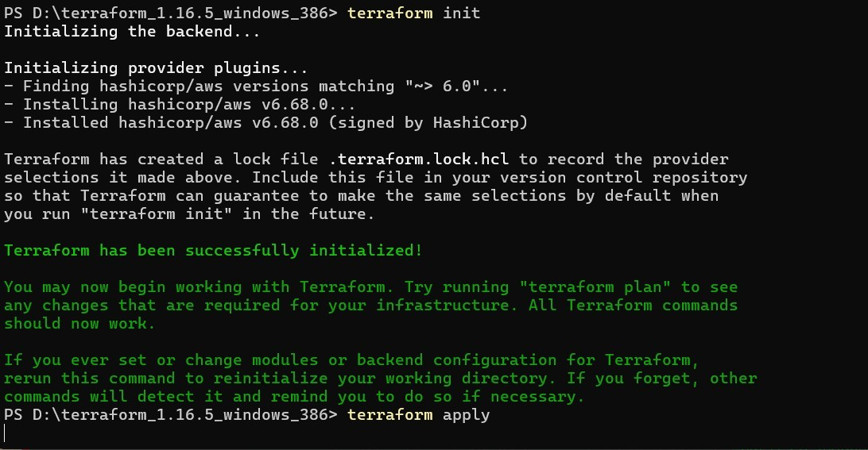
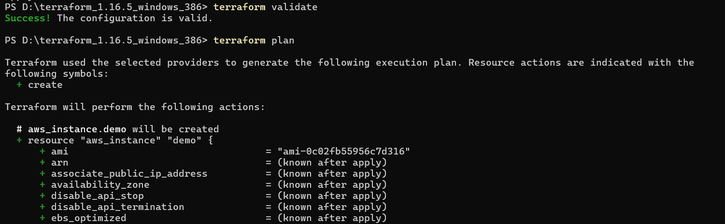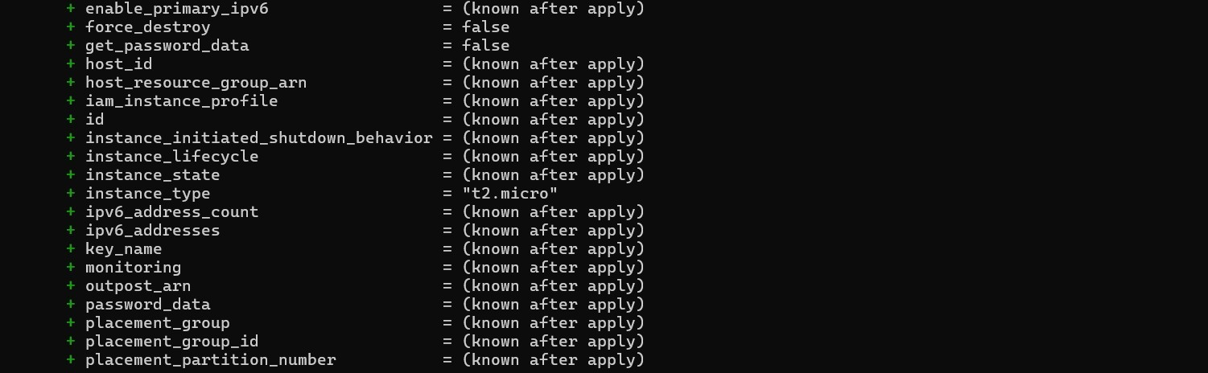

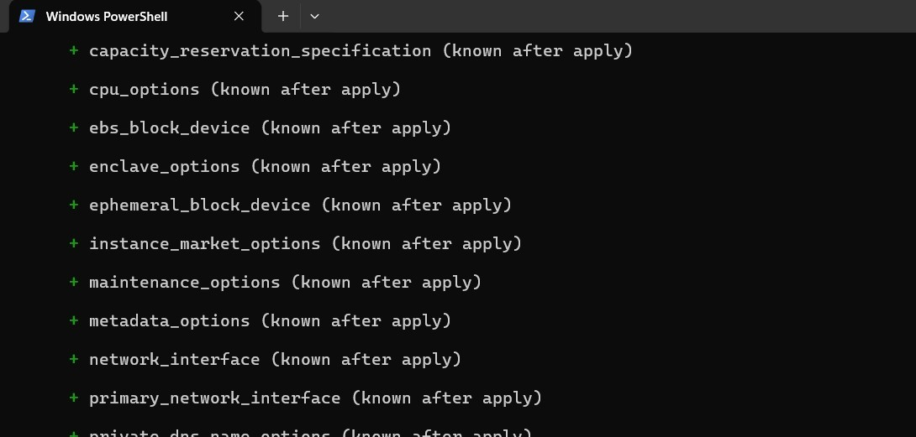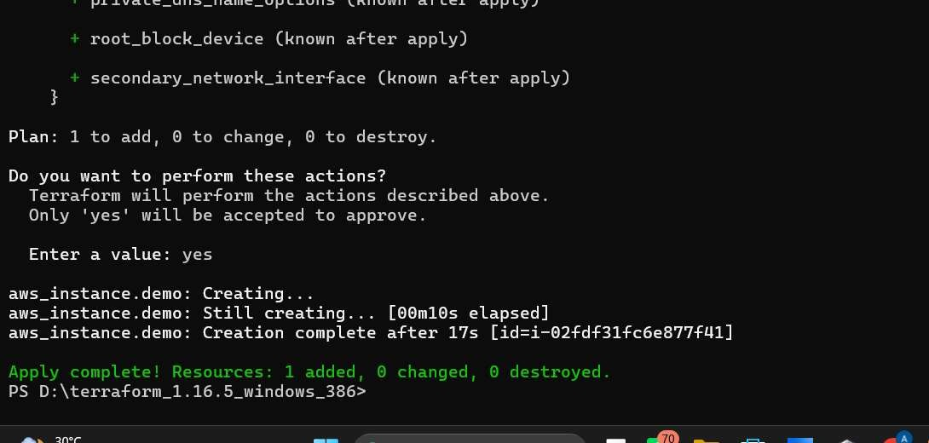
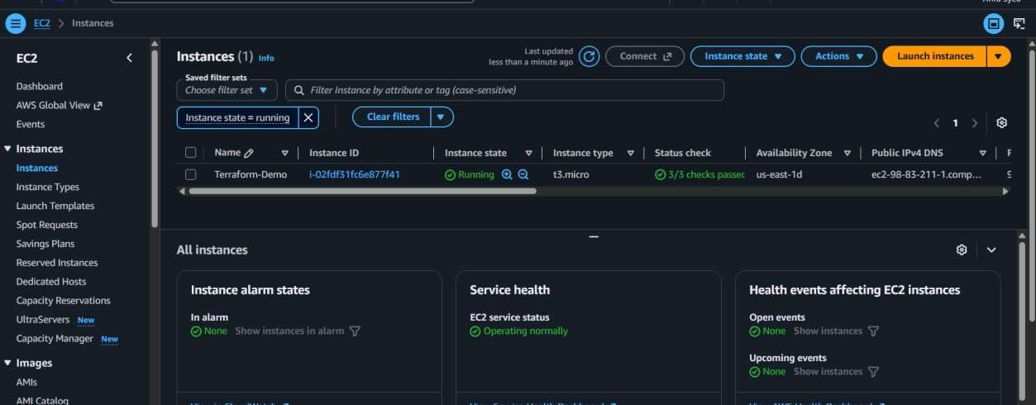

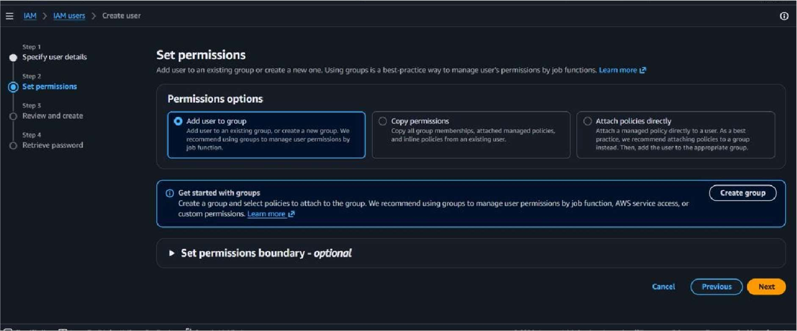
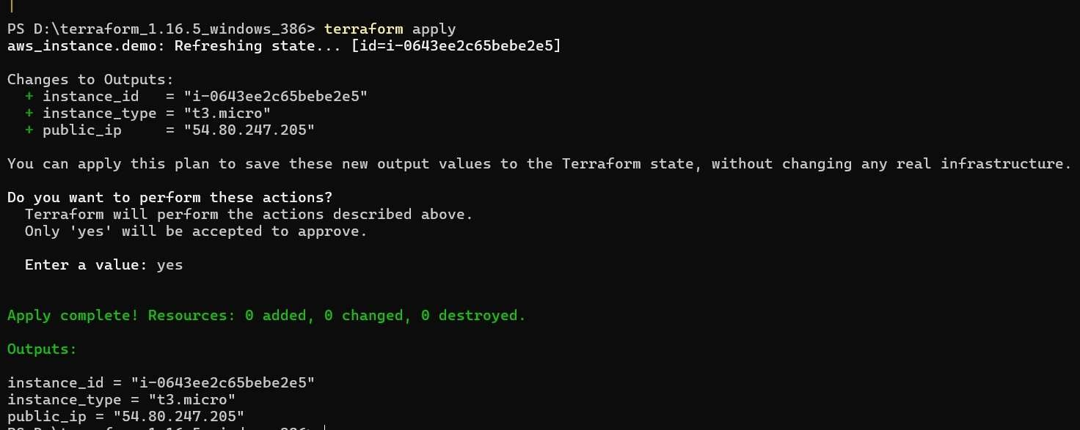

.tf files in the same folder are treated as one Terraform configuration. The filename does not determine what gets executed.

Output:

- Learning Outcomes Achieved :
Students gained practical knowledge of using Terraform to define, provision, and manage AWS cloud infrastructure through Infrastructure as Code (IaC).
- Conclusion:
  - Applications of the studied technique in industry
Terraform enables automated and consistent provisioning of cloud infrastructure, supporting efficient deployment and management of AWS resources.

  - Engineering Relevance
The experiment demonstrates Infrastructure as Code practices that improve scalability, reliability, repeatability, and efficiency in cloud-based engineering.

  - Skills Developed
Students developed skills in writing Terraform configurations, executing Terraform commands, and provisioning AWS resources using Terraform.

